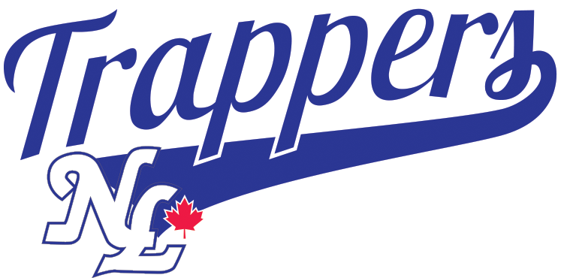

NORTH LANGLEY BASEBALL
13U A COACHES PACKAGE

INCLUDES:

13U A RULES
FIELD MAINTENANCE
PRACTICE PLANS

GENERAL RULES
- Full uniform and hats that are supplied by the league must be worn to all games - shirts are to be tucked in. It is mandatory that all players wear athletic supporters. Base runners, batter, and on-deck batter must wear batting helmets with chinstraps properly attached (or C-flap helmet).
- Each team is responsible to clean up their dugouts after the game.
- The Home team is responsible to prepare the diamond, line the field and fill in any depressions before the game. After the game they are to rake the infield, home plate and pitching mound areas and make sure all equipment used during the game is returned to the bins and locked up. Tarps should be returned to the home plate and mound areas. Bases should be left in place when another game follows but only if the other teams have started to arrive. No children are allowed in equipment room or bins.
- Before a game, each Head Coach must give a copy of his batting line-up to the opposing team and the home plate Umpire.
- During a game, Coaches or parents cannot position themselves on the outside of the backstop behind the umpire to coach the team. Loss of game can occur if after a warning the problem still exists. During game play if the defensive coaches are on the playing field they can only be in foul territory near their dugout or past their dugout towards the outfield.
- Coaches are responsible for the behavior of their team players, fans, and parents during games and to make sure that there is no abuse of the equipment.
- A 11U player may be called up to play on a 13U team a maximum of 5 games plus one tournament. The 11U & 13U Coordinators plus the player’s Coach must be notified of the name of the player being called up, to ensure that the player is eligible to be called up. The player must receive the same treatment as regular players, must not play more innings than a regular team player and must not pitch.
ENDING THE GAME
- Games must start within 15 minutes of the scheduled start time.
- It is solely the umpire’s discretion when to call the game due to darkness (should call open inning when light begins to fade), or for field or weather conditions.
- No new innings to begin after 2 hours and 15 minutes. Time limit applies to all games, regardless of light issues, following games etc.
- Extra Inning- In the event of a tie, ONE extra inning can be played if time limit and light permits.

INTERLOCK RULES – 2022
Interlock Playing Rules:

NOTE Please ensure that a copy of the attached Interlock Guidelines and Rules are circulated to all Umpires and Coaches so that they are aware of the following:

PROTESTS
No protests allowed during regular season Interlock play.
BALKS
13U A – warning only in April, 1 warning per pitcher in May, called in June
RUN LIMIT
5 runs per inning (except open inning)
ENDING GAME
Umpire’s discretion due to darkness (should call open inning when light begins to fade).
No new innings to begin after 2 hrs. 15 min. (all levels) – Time limit applies to all games regardless of light issues, following games, etc.

EXTRA INNING
In the event of a tie, ONE extra inning can be played if time limit and light permits.
RAIN-OUTS
Home team must contact the Visiting team within 72 hours to re-schedule a rain-out. They must offer a make-up date taking both team’s schedule/availability in to account. If the Visiting team can’t play first date, Home team must offer an alternative date. If the visiting team refuses second date, game may be scored as a default win for Home team. Conversely, if Home team does not contact the Visiting team within 72 hours, the Visiting team should advise Division Manager to request assistance as required in rescheduling of rainouts. If Home team refuses to provide a date for make-up game, then game may be scored as a default win for the Visiting team.

GENERAL RULES – SPECIFIC TO 13U

FAIRPLAY RULE All players must play at least three complete defensive innings of a six or seven inning game. All players must play at least two complete defensive innings of a five-inning game.

Fair Play – Enforcement - If a team is in violation of Fair Play the opposing coach will bring the issue to the offending coach as soon as it is discovered so that it can be corrected as best as possible. Violation of fair play will not result in a forfeit but may result in disciplinary action for the coach. The Division Coordinator should be notified of any Fair Play violations ASAP.
.

UMPIRES Before, during or after a game coaches or players may not approach an umpire for any reason except that they may:
(A) attend the plate meeting;
(B) request the Umpire to call “Time”;
(C) raise a safety concern;
(D) approach the Umpire to make a substitution on defense or offence;
(E) request the plate umpire to ask their partner for help on a half swing when the plate umpire calls the pitch a ball, but not when the pitch is called a strike. The plate Umpire will consult with the other umpire for a determination which will be final;
(F) approach the Umpire to protest a game based on an interpretation of the Rule of Baseball on terms as set out in this Rulebook.
(G) shake the Umpires hands post game;
(H) thank the umpires and or offer words of encouragement;

Coaches and/or Players at any time may NOT:
- Argue any Umpire’s decision which involves judgment, such as, but not limited to, whether a batted ball is fair or foul, whether a pitch is a strike or a ball, or whether a runner is safe or out, is final.

PITCHING RULES
The pitching rules are governed by a pitch count using the guidelines outlined in the pitching section of the BC Minor Rule Book, with certain amendments specifically for NCBA, NLBA & SCBA. All of Rule 23 (Pitching Rules) of the BC Minor Baseball Association shall apply in its entirety. Rest Rule Violation will result in a forfeit of the game to the opposing team. If a pitcher is about to exceed his/her maximum pitch count for the day the opposing manager and/or official scorekeeper and/or tournament director must inform the pitcher’s manager before the violation occurs. If a violation is discovered after it occurs the pitcher is simply removed from the mound and no further penalty will be invoked. Division Pitching Amendments: The pitching rules of the BCMBA shall be amended for play in CLOVERDALE INTERLOCK 2022:
- Balk rule is in effect. Warning only in April, 1 warning per pitcher in May, called in June
All BC Minor Baseball rules will be in effect

