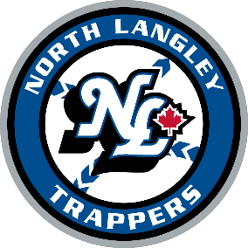
I hereby commit to be a coach of the North Langley Trappers. As a coach, I understand that how I carry myself on and off the field is critical – my behavior is modeled by players and parents while it may be dissected by the opposition. As such, I will do my best to follow these rules:
- I will set a good example by modeling the same basic expectations set for players and parents. If an expectation is reasonable for a parent or player, I should also be expected to follow those same standards.
- I will practice high ethical standards and only direct my team to play within the rules. We will always attempt to play within the rules of fair play, regardless of whether they are enforced.
- Not challenge judgment calls by the umpire. It is acceptable to question the interpretation of a rule, but only in a courteous non-confrontational manner. Shouting or gesticulating reactions to umpires’ call are unacceptable. Remember the younger umpires are in a learning phase and should be treated with dignity and encouragement. Concerns should be forwarded to the Umpire-In-Chief by using the form that is located on the website.
- I will have a thorough understanding of the rules of the game and those applicable to the tournaments we play.
- I will have clear, written team rules and expectations for players, parents and coaches. It is unfair to all if the rules and expectations are not in writing.
- I will consciously provide more positive than negative reinforcement. I understand that this significantly impacts a player’s passion to play the game and ability to learn.
- I will treat all our players with the respect they deserve. My role is to teach the game of baseball and some life lessons along the way. These are kids developing into young adults, and they all deserve my respect.
- I will arrive early, when possible, to practices and games to be sure that I am prepared prior to players arriving. Players should never wait for their coach to arrive with equipment and instruction.
- I will not risk the health of a player’s arm in an effort to win. I will obey pitch limits, remove a player who complains of a sore arm and practice caution to prevent arm injury.
- I will be a role model for my players regarding good sportsmanship, teamwork and self worth. I realize that players and families will often follow my lead. It is important that we all practice good sportsmanship and respect of others and ourselves.
- I will respect the opposing team, coaches, players and fans. While games can get intense, we will practice friendly competition and show respect for our opponents.
- I strive to have every kid return to the sport next year by the example I set forth
I understand these rules, and I will do my best to always represent this team and my child well.
I also agree that if I fail to abide by the rules and guidelines, I will be subject to disciplinary action that could include, but is not limited to the following:
- Verbal warning by umpires, coach director, and/or president of NLB
- Written warning
- Coach game suspension with written documentation of incident kept on file by NLBB.
- Coach season suspension

Name, Signature ___________________________________________________________
Date _____________________________________

